Given the root of a binary tree, return the most frequent **subtree sum**. If there is a tie, return all the values with the highest frequency in any order.

The **subtree sum** of a node is defined as the sum of all the node values formed by the subtree rooted at that node (including the node itself).

**Example 1:**

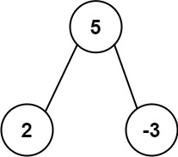

**Input:** root = [5,2,-3]

**Output:** [2,-3,4]

**Example 2:**

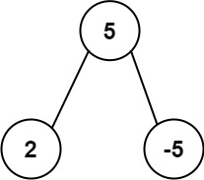

**Input:** root = [5,2,-5]

**Output:** [2]

**Constraints:**

* The number of nodes in the tree is in the range [1, 104].
* -105 <= Node.val <= 105